KUNSHAN XINXIA PLASTIC PACKAGING CO., LTD.
Plant No. 6, Zhengyuan Chuanghui Science and Technology Industrial Park, No. 169 Shimeng Road, Kunshan City, Jiangsu, China
TECHNICAL DATA SHEET | 7-Layer Composite Sealing Liner
Product / 产品: 7-Layer Composite Heat-Seal Liner / 七层复合热封垫片 | Diameter / 直径: Ø88 mm
Parameter / 参数 | Specification / 规格
Applicable containers / 适用容器 | PP, PE or PET containers / PP、PE或PET材质容器
Overall thickness / 总厚度 | Customizable: 1.0 mm or 1.5 mm / 可定制1.0 mm或1.5 mm
Construction / 结构 | 7-layer composite structure / 七层复合结构
Application / 用途 | Container opening sealing / 容器口部封口
LAYER STRUCTURE / 七层结构
No. | Layer / 层次 | Original drawing label / 原图标注
1 | PET Printing Layer / PET印刷层 | 1.2C
2 | PET Film / PET薄膜 | 2.5C
3 | EPE Foam Layer / EPE发泡层 | 0.5C
4 | PET Film / PET薄膜 | 5C
5 | Functional Coating Layer / 功能涂层 | 5C
6 | Aluminum Foil Layer / 铝箔层 | 1.8C
7 | Heat-Seal Layer / 热封层 | 2C
STRUCTURE ILLUSTRATION / 结构示意图
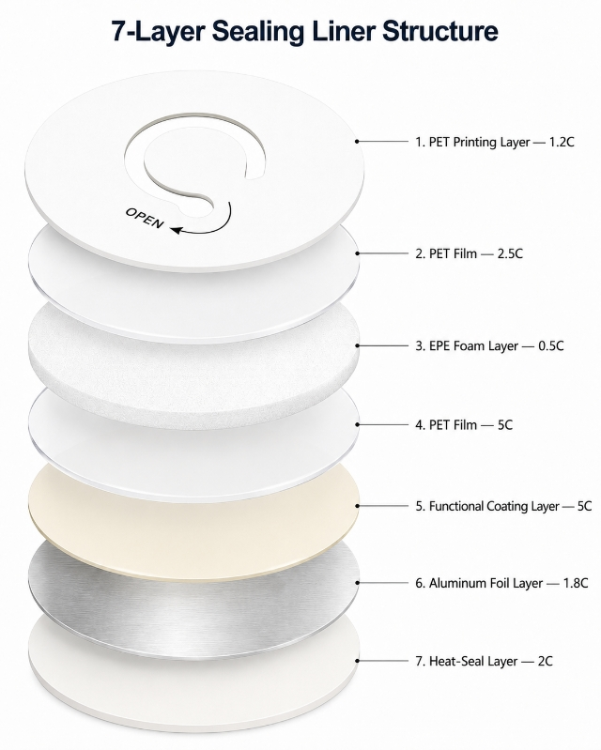
NOTES / 备注
1. The “C” layer-thickness labels are reproduced from the supplied diagram; units and layer build-up require confirmation. / 各层“C”厚度标注沿用原图，单位及叠层厚度需确认。
2. Total thickness options (1.0 / 1.5 mm) are customization targets, not the sum of the unverified layer labels. / 总厚度为可定制目标，不代表原图各层厚度已核算。
3. Heat-seal performance and compatibility must be validated on actual PP, PE or PET containers before mass production. / 量产前须按实际容器进行热封及相容性验证。
www.xinxia-package.com

